**University Social Network Platform**

**Problem Domain**

Dedicated university messaging platform is very helpful to distribute messages with large crowd very easily. When I was in university we organized many functions like sports festivals, music concerts, video gaming competitions, drama festivals etc. As well as we had subject revision classes held before our semester examinations. For organizing these functions we need human force and way to convey messages effectively. Putting a message using common messaging platform to inform about these kind of gatherings was not very successful. Some will see and some will don not see these messages in time. So, students will miss these events. And there were lot of time waste due to these ineffectiveness. Student use these common media for their personal use. As well as these free platforms has limited user capacity most of the time. As well as we can use this platform to share new ideas, thoughts with each other. So having a separate specific platform for communication inside university will be very helpful for convey messages instantly and effectively to large number of students.

**Introduction**

In this project we introduce social media platform for effective communication within university students. Using this platform they can share information or share their thoughts and opinions and share their creative ideas with others. So, students can receive outside interest by likes and dislikes and student opinions will be recognize within community. As well as event organizers can inform and update students about ongoing events. Appointed administrator from each faculty will monitor the social media platform and its contents regularly.

**Functionalities**

1. **Student(User)**
   1. Can create own user account
   2. Can create posts
   3. Can view other posts
   4. Can like or dislike user posts
   5. Can update their own profiles
   6. Can delete their own profiles
2. **Administrator**
   1. Can remove existing students
   2. Can remove user posts
   3. Can post announcements
   4. Can list down all users using filters
   5. Can view story thread

**System Services**

1. User service – Users can create/update/delete own account
2. Announcement service – Admin post important announcement to users
3. Filter service – Admin can filter users using filter service (By faculty). Student can filter user posts by its origin time.
4. Post service – Users can create/update/delete own posts
5. Admin Service – Admin can filter users, create/update/delete user posts and their accounts

**User Roles and their Capabilities**

|  |  |
| --- | --- |
| Users | * Create, update, delete own posts * Create, update, delete own account * View user posts * Filter posts |
| Admins | * Delete users * View and Delete user posts * Create, Update, Delete announcements * Filter users |

**Security Enforcement**

* Student email/username should be match with the university email domain
* User password should be match with given pattern
* Student cannot delete other user posts or other users
* Admin cannot update user profiles

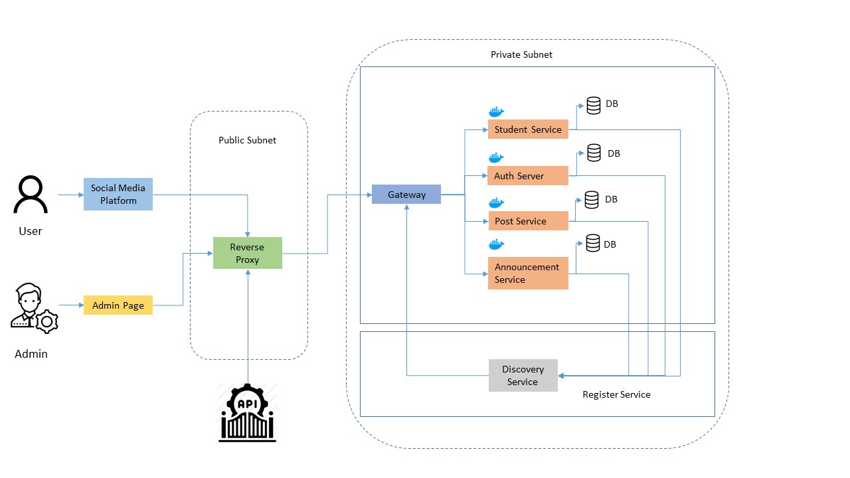**Proposed Project Design**

**Project Scope**

In this project we try to implement web version with above mentioned functionalities.

**System Entities**

1. Student
2. Administrator
3. Post
4. Announcement

**Technical Requirements**

* Operating system: Windows 10
* Programming Languages (Backend): Java, MySQL
* Programming Languages (Frontend): Angular
* Other Technologies: HTML, CSS, Hibernate, Spring Boot, Docker, GitHub, Micro services
* Software: IntelliJ IDEA, Visual Studio Code, WampServer, Chrome web browser, Command line tool

**Project Duration**

6 weeks